Schacherl, & Schacherl
346 E. Washington St.
Madison, WI 53703
Phone: 608-417-1652 • Fax: 628-243-0176 • Email: schacherl@schachlaw.com

October 26, 2018

US MAIL

Frank Zambo
123 Main St.
Suite 456
Madison
WI 53718

Re: Your failure to Answer Interrogatories in the matter of Brown v. Green, Dane County Case No. 2018 CV.

Dear Mr. Zambo:

As you know, our office represents Mr. Chris Brown in the above case. Our office sent you interrogatories on September 18, 2018. The deadline for answering was October 22, 2018. They were not answered.

Our office made multiple attempts to remind you. We called and left voicemails on Tuesday, October 23; Wednesday, October 24; and Thursday, October 25. We received no response. We sent emails on each of the above days, and we received no response. We also sent a member of our team to your office to discuss the interrogatories. Unfortunately, you were unavailable.

We do not know why you have failed to answer our calls and emails. Our client has agreed to extend the deadline to 4:30 pm on Friday, November 2, 2018. If we are forced to bring the Motion to Compel, I will also be seeking an award of expenses incurred in obtaining the order, including my actual attorney fees, as allowed under Wis. Stats. § 804.12(1)(c)1. I hope this will not be necessary.

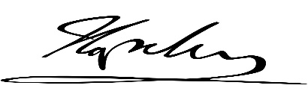
Sincerely,

____________________
Anne Schacherl
Attorney at Law

AS.

cc: Bob Johnson
File

Enclosure: (1)

